Hands-on Exercise No. 3  DigiSkills 3.0 Batch-03  Data Analytics and Business Intelligence | Total Marks: 10  Due Date: 04/06/2026

Hands-on Exercise No. 3
Data Analytics & Business Intelligence
DigiSkills 3.0 Batch-03

Name: | Zain Latif
Date: | 04-06-2026
Course: | Data Analytics & Business Intelligence

1. Create calculated columns: (Marks – 3)
To categorize sales into High and Low based on the Sales value, where values greater than 100 are labeled as High and others as Low. Name the new column as Sales Category
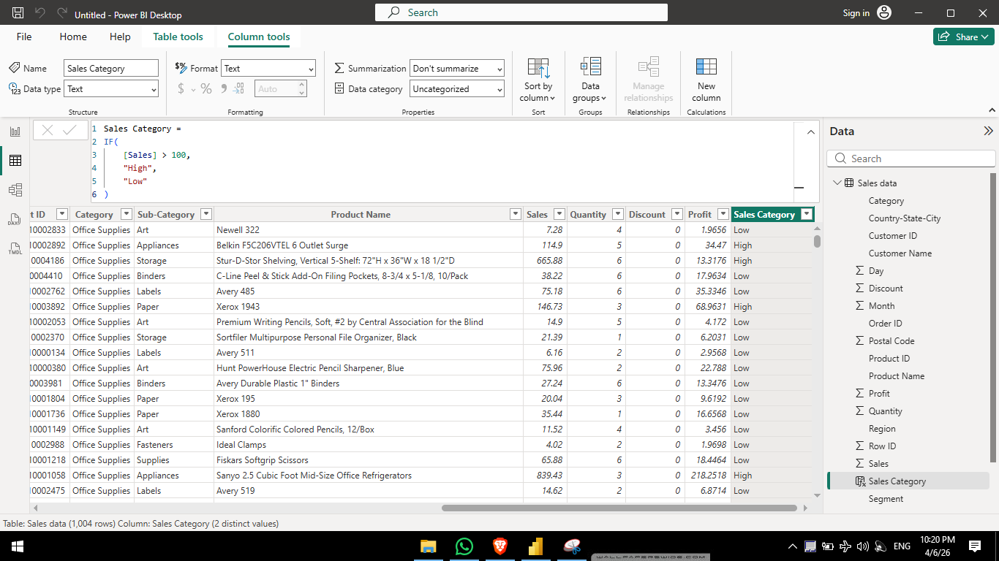
To classify records based on discount, labeling entries with zero discount as “No Discount” and others as “Discount Applied”. Name the new column as Discount Category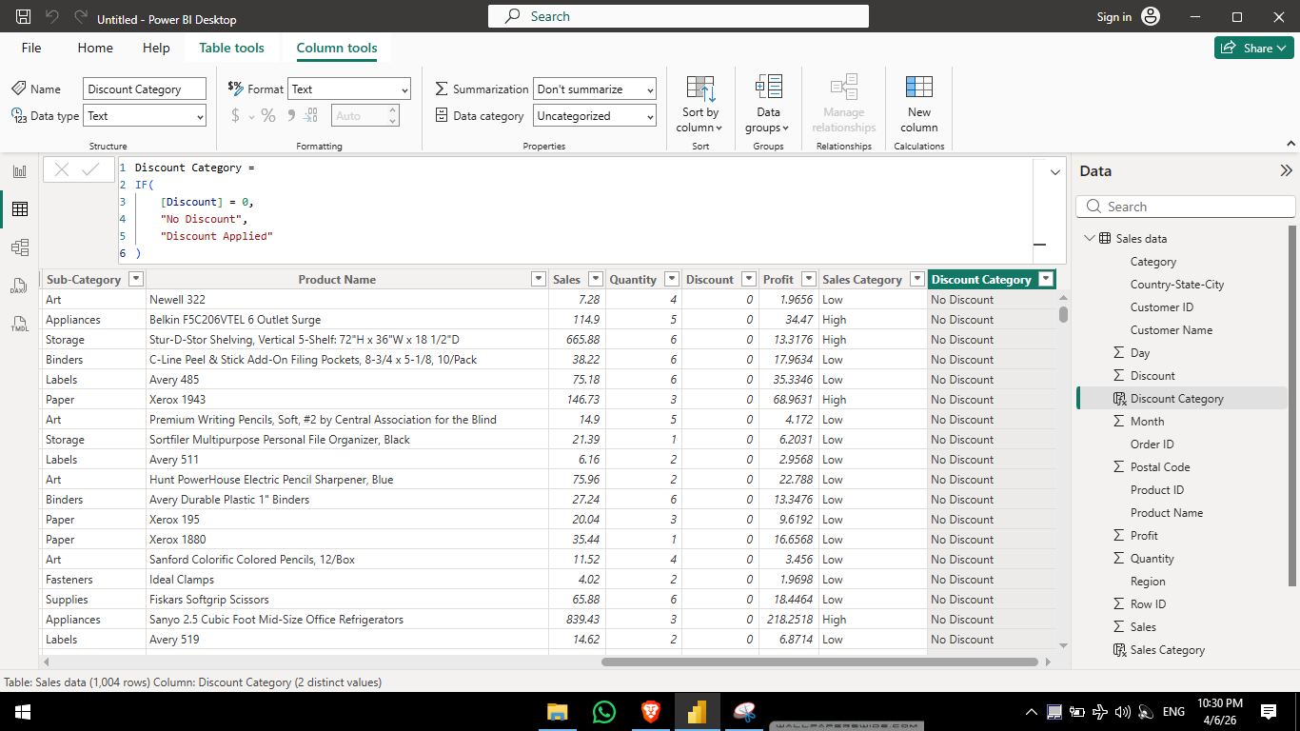

2. Create calculated measures: (Marks – 5)
find Total Sales (Sum of Sales)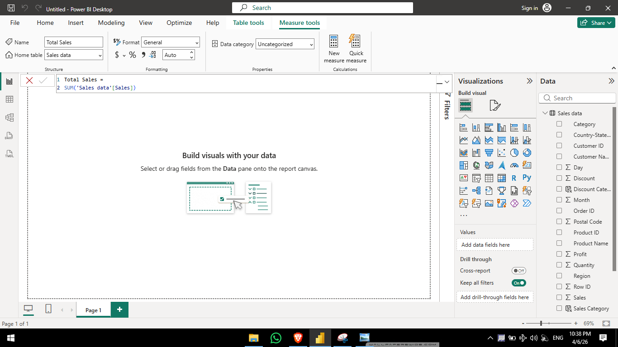
• Qty Sold (Sum of Quantity)
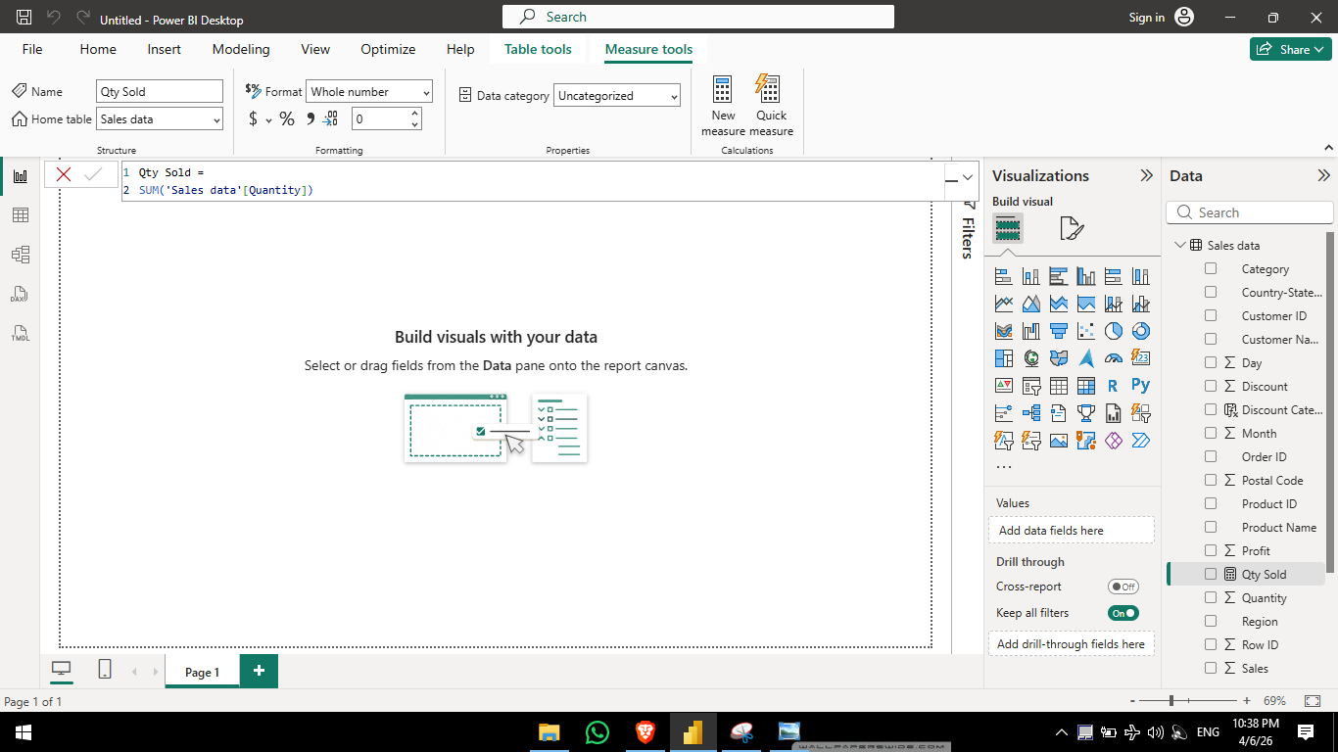
• Total Orders (Count of Order ID)
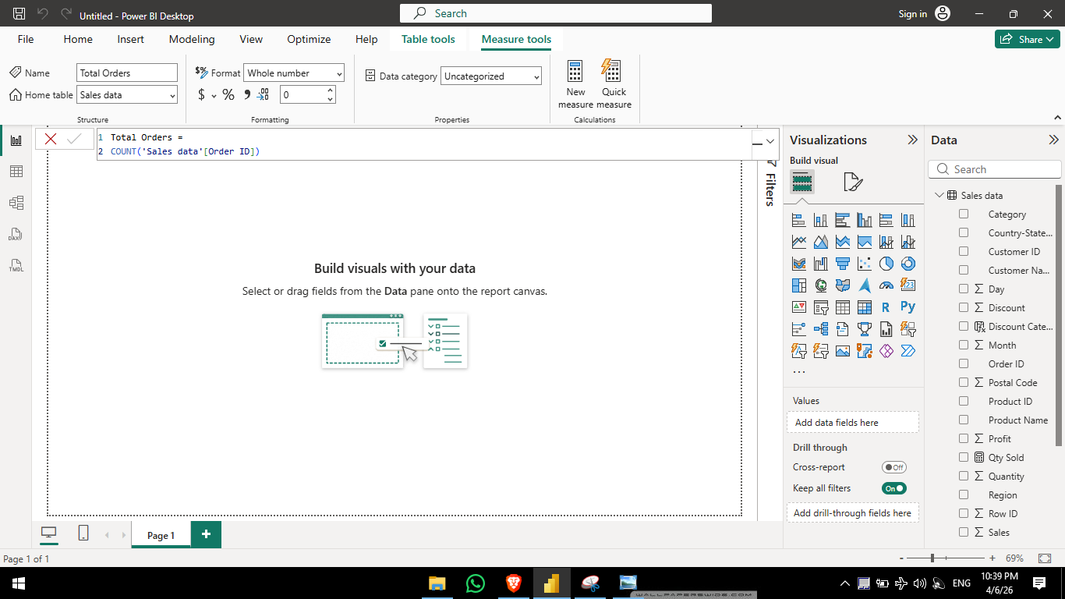
Total Profit (Calculate by multiplying quantity by profit) using iterator function
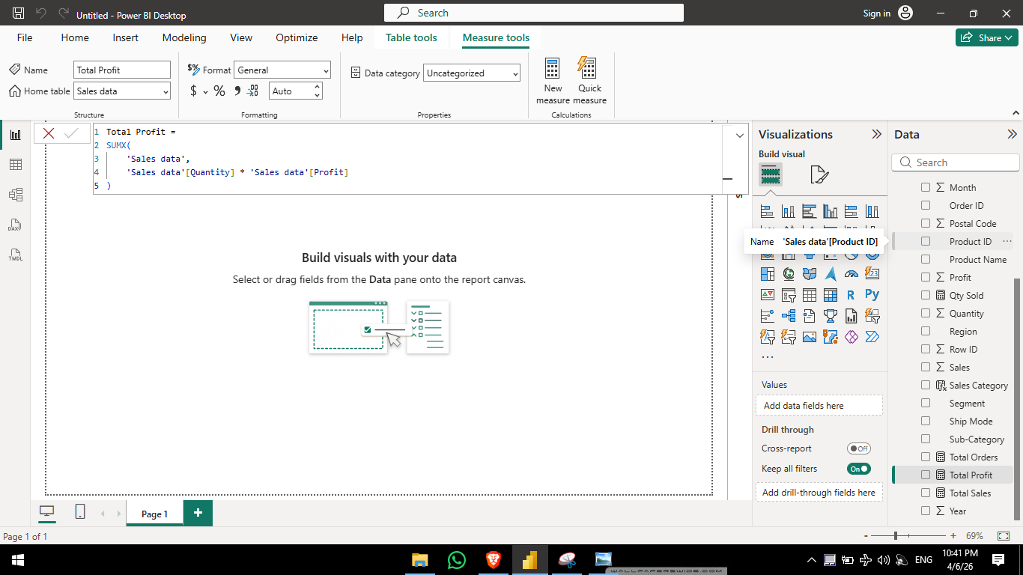

3. Validate all the results of calculated measures by using the Matrix visual. (Marks – 2)
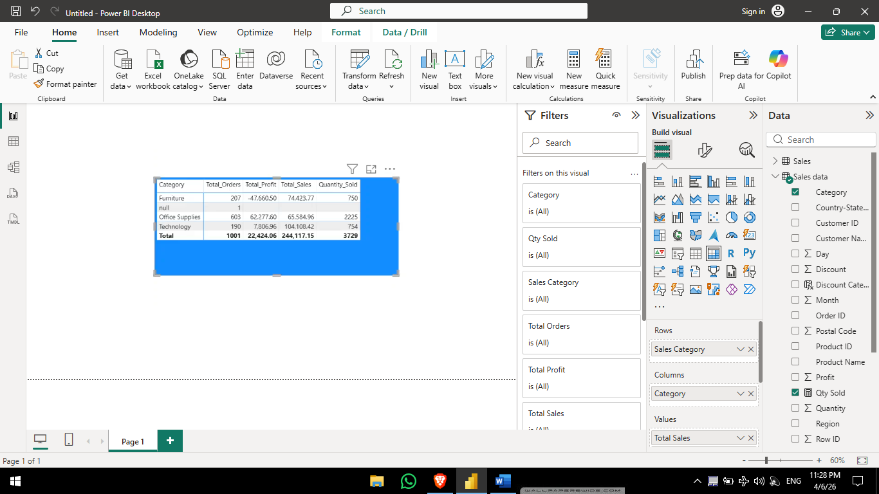

Task 5: Split the column into three separate columns named: Country, State, and City.
The dataset contains a column named Country-State-City that combines Country, State, and City information using hyphens as separators. For example: United States-Kentucky-Henderson
